WCP: This is Project Development Plan template version 2.0 of 2014-10-21

Gain/Phase Analyzer

Project Development Plan

Watson Capstone Project WCP52

Sponsor: Professor Kyle Temkin

October 24, 2014

Revision: A

Submitted by:

Christopher Pavlina, Lead, EE

Kaidi Xu, EE

Harrison Owens, CE

Ken Zach, CE

Faculty Advisor: Professor Kyle Temkin

Program Manager: Professor Jack Maynard

Approved for public release; distribution is unlimited.

Submitted in partial fulfillment of EECE 487-488 / ME 493-494 requirements.

Thomas J. Watson School of Engineering and Applied Science

Binghamton University

Binghamton, NY

Table of Contents

[WCP: Use the heading styles! Tab and shift-tab will changes heading levels.  
Right-click to select Update Field when done editing.]

1. Scope 4

1.1 Identification 4

1.2 System Overview 4

1.3 Document Overview 4

2. Referenced Documents 5

3. Overview of Required Work 5

3.1 Context-Level Constraints 6

3.2 System-Level Constrants 6

3.3 Project Documentation 7

3.4 Project Schedule and Resources 7

4. Plans for System Development Activities 7

4.1 Project Planning and Oversight 7

4.2 Data Management 8

4.3 System Requirements Analysis 8

4.4 System Design 8

4.5 Handling of Critical Requirements 8

4.6 Hardware Resource Utilization 9

4.7 Joint Technical and Management Reviews 9

4.8 Other Development Activities 9

5. Plans for Hardware Development Activities 9

5.1 Hardware Development Process 9

Hardware Development Methods 9

Standards for Hardware Products 9

Establishing a Hardware Development Environment 10

5.2 Hardware Requirements Analysis 10

5.3 Hardware Design 10

5.4 Hardware Implementation and Unit Testing 10

5.5 Unit Integration and Testing 11

6. Plans for Software Development Activities 11

6.1 Software Development Process 11

Software Development Methods 11

Standards for Software Products 11

Establishing a Software Development Environment 12

6.2 Software Requirements Analysis 12

6.3 Software Design 12

6.4 Software Implementation and Unit Testing 12

6.5 Unit Integration and Testing 12

7. Plans for System Integration and Test Activities 12

7.1 Hardware/Software Integration and Testing 13

7.2 System Qualification Testing 13

7.3 Preparing for System Use 13

7.4 Preparing for System Transition 14

7.5 Configuration Management 15

7.6 Product Evaluation 15

7.7 Quality Assurance 15

7.8 Corrective Action 15

8. Project Organization and Resources 15

8.1 Project Organization 15

8.2 Project Schedules and Activity Network 16

8.3 Project Finances 16

8.4 Project Resources 17

8.5 Acronyms and Abbreviations 18

9. Appendices 18

Appendix A – Detailed Project Schedule 18

List of Figures

[WCP: Add the caption to a figure elsewhere with Insert/Reference/Caption, Figure.  
Right-click here to select Update Field when done editing.]

Figure 1: Gain/Phase Analyzer Context Diagram 6

Figure 2: Gain/Phase Analyzer System Diagram 7

Figure 3: Top-level Gantt chart, Fall 16

Figure 4: Top-level Gantt chart, Spring 16

Figure 5: Detailed Fall Schedule 19

Figure 6: Detailed Spring Schedule 19

List of Tables

[WCP: Add the caption to a table elsewhere with Insert/Reference/Caption, Table.   
Right-click here to select Update Field when done editing.]

Table 1: Project Finance Estimation 17

WCP: Read these planning document requirements carefully as a team, comparing interpretations. Some sections may not be applicable, some may have very easy answers, and some may use terminology you’ve never heard before. Think about how you’re actually going to do your project, then use this to help form a plan that you can work to for the rest of the academic year. With suitable revisions along the way, subject to Customer and Program Manager approval, of course.

WCP: All sections of this document are required. If a section is not applicable, that, and explain why it ’s not.

WCP: Add your text in the Normal style. After your document if fully approved, ‘Select All’ of the Guidance style paragraphs and delete them, leaving your own project-specific document.

# Scope

This section shall be divided into the following subsections.

WCP: No text needed here – it’s a top-level heading with subsections.

## Identification

This section shall contain a brief identification of the system to which this document applies.

WCP: E.g., “This development plan is for the Watson Capstone Project <WCPnn> <Project Name> of <year-year>”.

This development plan is for the Watson Capstone Project WCP52 Gain/Phase Analyzer of 2014-2015.

## System Overview

WCP: Describe the purpose, scope, and background of your project. Include enough detail so that someone knowledgeable in the field can understand the subject. Identify the sponsoring organization, client organization (if any), and planned operating site.

WCP: Do not describe the system beyond the top level as shown in your system diagram. Your system architectural details and detailed design belong in later documents.

A Gain/Phase Analyzer is an instrument used to plot the frequency response of a network or amplifier. The project, sponsored by Professor Kyle Temkin, specifies a small, computer-controlled gain/phase analyzer for use by students and individuals. It can stimulate and then measure filters, amplifiers and control systems, allowing their behavior to be plotted and analyzed. The device is to be developed as an open-source project, so that students may study its inner workings.

## Document Overview

WCP: Use this boilerplate:

This development plan describes the overall project, the system, hardware, and software development activities, the system integration and test activities, and the project organization and resources necessary to carry out hose activities.

# Referenced Documents

This section shall list the number, title, revision, and date of all documents **incorporated by reference** in this plan. This section shall also identify the source for all documents not available from Watson Capstone Projects.

WCP: Start with this boilerplate:

The following documents of the exact issue shown form a part of this document to the extent specified herein.

Watson Capstone Projects Master Statement of Work 2014-2015 Version, Rev. B of 2014-07-23.

WCP52 Gain/Phase Analyzer Project Requirements Specification (PRS) Rev. B of 2014-10-17.

WCP52 Gain/Phase Analyzer C Coding Style Guidelines (C-CSG), Rev. 82c2644 of 2014-10-24 or more recent. Accessible: <https://github.com/WCP52/docs/commits/master/WCP52-C-CSG.rst>

Python Software Foundation PEP-8 Style Guide for Python Code, Rev. e98737176f1d of 2014-08-31. Accessible: <http://legacy.python.org/devs/peps/pep-0008/>

WCP: Since you will be referencing the WCP Master SOW and your Project Requirements Specification later in this plan, list them here. E.g., “Watson Capstone Projects Master Statement of Work 2013-2014 Version, Rev. B of 2014-07-23” and “WCP99 Portable Fusion Reactor Project Requirements Specification (PRS) Rev – of 2013-04-01.”

# Overview of Required Work

WCP: This section may be divided into sections as needed to establish the context for the planning described in later sections. It shall include, as applicable, an overview of:

1. Requirements and constraints on the system, hardware, and software to be developed
2. Requirements and constraints on project documentation
3. Position of the project in the system life cycle
4. Requirements and constraints on project schedules and resources
5. Other requirements and constraints, such as on project security, privacy, methods, standards, interdependencies in hardware and software development, etc.

WCP: Include your Context Diagram and your System Diagram, and write descriptive sentences that reference them. (E.g., As shown in Figure 1, Portable Fusion Reactor Context Diagram, the user interface and the fuel supply …).

WCP: Summarize! State simply what you must do: develop a system that meets the requirements in your PRS, noting the major requirements and constraints. What are the major issues you ’ll be dealing with?

WCP: In the paragraph where you summarize your requirements, conclude with a statement like “Further details of our system requirements may be found in the WCP99 Portable Fusion Reactor Project Requirements Specification (PRS).”

## Context-Level Constraints

This project is to produce one gain/phase analyzer system. As shown in Figure 1: Gain/Phase Analyzer Context Diagram, the device is to connect to a PC for user control and viewing of data. It is to have one *Drive* output, with which it applies a stimulus to a Device Under Test (DUT), and two *Sense* inputs, with which it detects the amplitude and phase of signals before and after the DUT. The device will also have an *Adapter* port, with which it can connect to external adapters for measuring various types of DUTs.

The gain/phase analyzer system, in addition to the hardware, will comprise PC *Software* with which the end user may start analyses and view results.

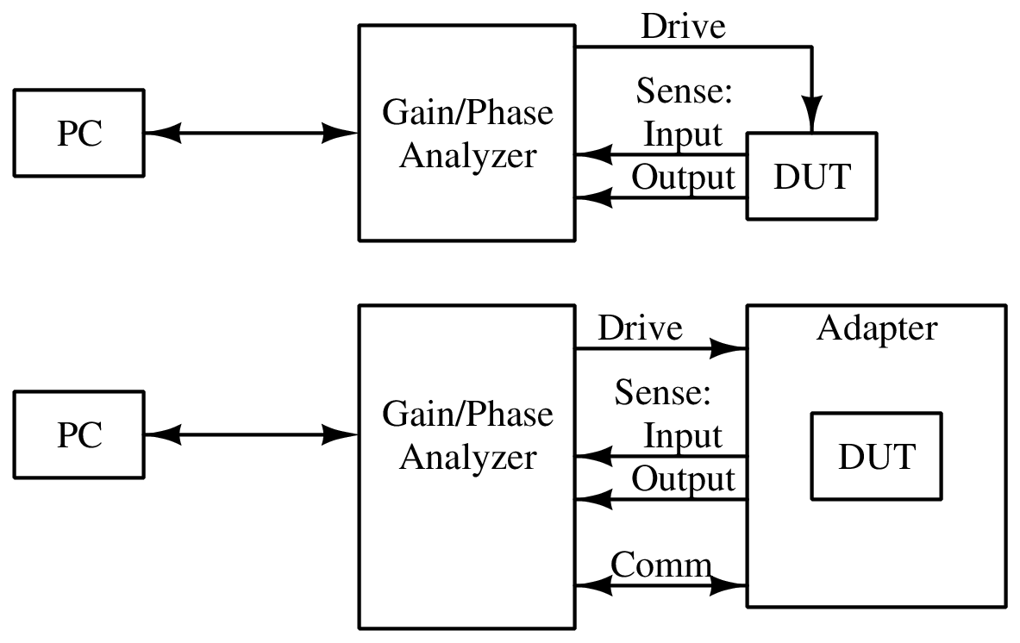

Figure 1: Gain/Phase Analyzer Context Diagram

## System-Level Constrants

As shown in Figure 2: Gain/Phase Analyzer System Diagram, the analyzer will use a *Synthesizer* to generate the stimulus signal, and an *Output Amplifier* to provide the stimulus signal to the DUT, at up to 1.25 V RMS and up to 150 MHz. *Input Filters*, an *Input Switching Network* and the *Input Detector* will provide a signal corresponding to the amplitude of the signals at the *Sense* ports. The Input Switching Network can also select a *Phase Reference* to be summed with the signals for phase measurement. These will be digitized by an *Analog-Digital Converter* to be processed by the *Microprocessor*. The Microprocessor will then interface with the *Software* via the *PC Interface*.

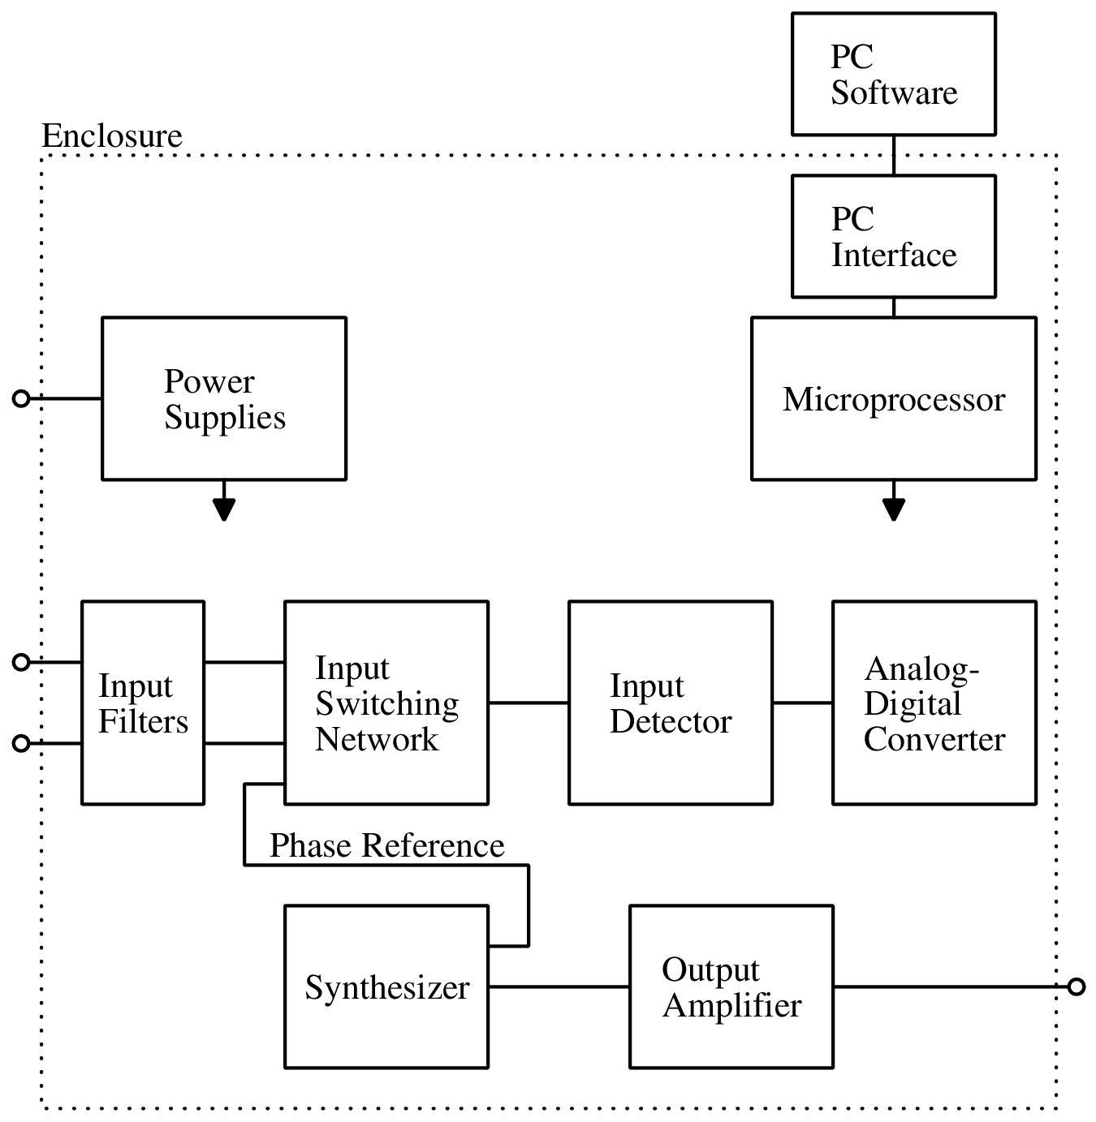

Figure 2: Gain/Phase Analyzer System Diagram

## Project Documentation

The gain/phase analyzer will be provided with a *Protocol Guide*, describing the method of interacting with it from a PC. It should also include an *Operator's Manual*, explaining its system-level design and providing basic instructions for its use.

## Project Schedule and Resources

# Plans for System Development Activities

WCP: No text needed here – it’s a top-level heading with subsections.

## Project Planning and Oversight

WCP: Use this boilerplate:

This development plan will be updated, if necessary, at the start of the Spring semester. Test planning, and if applicable, installation planning, will also be done then.

## Data Management

WCP: Describe how will you manage any data from your customer, vendors, and other sources that you acquire for your project. Perhaps kept in a folder on a shared drive with automatic version history, such as Google Drive?

Documents related to WCP administration will be kept in a shared folder on Google Drive, providing version history and common access.

Internal documents will be kept in our shared Git repository, which our Faculty Advisor has elected to access directly.

## System Requirements Analysis

WCP: Describe how you did your requirements analysis when you reviewed the project proposal requirements as a team, discussed them with your Customer (stakeholder interviews), and while fitting them into the categories provided by the Project Requirements Specification template. You may also have prepared an operational concept or some informal Use Cases.

Our Faculty Advisor, who is also our Sponsor, met with us to discuss the requirements for our project. We reviewed the principles of operation and a few possible methods of implementation. Some initial circuit design and simulation was performed to evaluate the viability of requirements. Major use cases were exercises by students, as the device is targeted at education.

## System Design

WCP: Describe how you’ll be doing what was presented to you in the Conceptual Design lecture. Mention any trade studies you’ll be performing, and which techniques you’ll use to do them. Also describe the use of any system-level modeling and analysis tools, e,.g., Matlab, that you will be using.

Our project is one without many various and viable implementation possibilities. As such, many major decisions will involve study of other instrumentation which performs similar tasks, including a few open-source network analyzers. Trade study will be used as required for selecting high-cost components or designs of subsystems, and this will be addressed as necessary during the development cycle.

Modeling and analysis will be performed using SPICE simulation and mathematical software like MATLAB, Octave or Mathematica.

## Handling of Critical Requirements

WCP: Describe how ensure the critical requirements, if any, are given priority in your system design and testing effort. Suggestion (deleting either the square brackets or the phrase with them as appropriate to your project):

All requirements defined by our PRS Section 3.7 were deemed to have equal weight.

## Hardware Resource Utilization

WCP: Describe the approach to be followed for allocating hardware resources (e.g., computer, weight) and monitoring their utilization. Most likely, you can say:

There are no critical hardware resources to be allocated on this project.

## Joint Technical and Management Reviews

WCP: Use this boilerplate:

In compliance with the WCP Master Statement of Work, the following reviews will be held on the progress of this project:

• System Requirements Review (SRR)

• System Design Review (SDR)

• Preliminary Design Review (PDR)

• Critical Design Review (CDR)

• Test Plan and Procedures Review (TPPR)

• Test Readiness Review (TRR)

• System Acceptance Review (SAR)

## Other Development Activities

WCP: Describe the approach to be followed for other development activities (e.g., risk management, security and privacy, etc.). Most likely, you ’ll say:

There are no other development activities planned for this project.

# Plans for Hardware Development Activities

WCP: **If** the system the project is developing will have no hardware components, you may state “This section is not applicable, as the system being developed will have no hardware components”, and delete the remaining subsections of Section 5.

WCP: Otherwise, no text is necessary here, as subsections follow.

## Hardware Development Process

Hardware Development Methods

WCP: Describe or reference the hardware development methods to be used. Include descriptions of the manual and automated tools and procedures to be used in support of these methods. Mention any modeling, analysis, and layout tools, e,.g., Matlab, Creo, Visio, Spice, Eagle, that you will be using.

Standards for Hardware Products

WCP: Describe or reference the standards to be followed for representing requirements, design, assemblies, test cases, test procedures, and test results. Consider including:

1. Standards for drawing formats
2. Naming conventions for variables, parameters, assemblies, files, etc.
3. Restrictions, if any, on the use of materials
4. Safety factors

WCP: Describe standardizing on Creo or Eagle data files, resistor naming convention, variable names, material restrictions, required safety factor, etc.

Establishing a Hardware Development Environment

WCP: Describe the approach to be followed for establishing, controlling, and maintaining a hardware development environment. I.e., describe what machine tools, painting facilities, soldering systems, etc. will be needed, and where they are.

Hardware should be designed using LTspice (or equivalent SPICE simulator) for circuit analysis, KiCad for schematic capture and printed circuit board (PCB) layout, and MATLAB, Octave, or Mathematica for any necessary mathematical analysis.

Schematics should be drawn, as much as possible, in a sparse, self-documenting format, with accompanying descriptions and labels, and using the hierarchical schematic format.

The PCB shall be designed in no more than four layers, and should avoid leadless packages when possible.

No voltages higher than 30 V peak-to-peak shall be present outside the device, and no voltages higher than 40 V peak-to-peak shall be present inside the device, to ensure electrical safety.

## Hardware Requirements Analysis

WCP: Use this boilerplate:

The hardware requirements analysis was performed as part of the System Requirements Analysis described in Section 4.3.

## Hardware Design

WCP: Describe how you ’ll design your project hardware. E.g., you could say:

The engineering design methods described in Section 4.4: System Design, and the methods and computer-aided engineering (CAE) tools described in Section 5.1, Hardware Development Process, will be used to develop the hardware design.

## Hardware Implementation and Unit Testing

WCP: How will you built hardware components, and how will you test them prior to integration with other parts? Will you outsource any manufacturing (e.g., circuit boards)?

Initial prototype circuit boards will be manufactured either by an external fabricator, selected at the time according to our specifications, or internally by the team. Final circuit boards will be manufactured by an external fabricator, which will be selected at the time according to our specifications.

Initial prototype circuit boards will be designed to allow external test and characterization, as much as possible, in the absence of the remainder of the system.

## Unit Integration and Testing

WCP: Describe how you will integrate individual hardware components into hardware assemblies, and if planning to test integrated hardware subsystems, how you will do that.

There is only one final, monolithic hardware component, the final Printed Circuit Board in its enclosure. Subcircuits on this board will be designed with interconnections that can be removed for separate testing.

# Plans for Software Development Activities

WCP: **If** the system the project is developing will have no software components, you may state “This section is not applicable, as the system being developed will have no software components”, and delete the remaining subsections of Section 6.

WCP: Otherwise, no text is necessary here, as subsections follow.

## Software Development Process

Software Development Methods

WCP: Describe the software development methods to be used e.g., structured procedural programming, object-oriented programing, model-drive programming. Include descriptions of the manual and automated tools and procedures to be used in support of these methods.

Standards for Software Products

WCP: Describe the coding standards to be followed for each programming language to be used, including:

1. Standards for format (such as indentation, spacing, capitalization, and order of information)

Software written in C and similar languages (*e.g.* C++) will follow the style described in “WCP52 Gain/Phase Analyzer C Coding Style Guidelines (C-CSG)”. Programs written in Python will follow the style described in “Python Software Foundation PEP-8 Style Guide for Python Code”.

1. Standards for header comments (for example, name/identifier of the code; purpose; notes on the processing (such as algorithms used, assumptions, constraints, limitations, and side effects); and notes on the data (inputs, outputs, variables, data structures, etc.)

Functions should be preceded by comments which describe inputs, outputs, preconditions, postconditions and side effects, where applicable; for more information see the “C-CSG”. Files shall contain header comments consisting of file names, authors or contributors and a brief description of the purpose of the file.

1. Standards for other comments (such as required number and content expectations)

The number of comments will not be specified.

1. Naming conventions for variables, parameters, packages, procedures, files, etc.

All naming conventions will follow the format specified in the relevant, external style guide.

Establishing a Software Development Environment

WCP: Describe software development environment and toolchain, e.g., Eclipse and the GNU Compiler Collection (GCC) (where GNU stands for GNU's Not Unix!).

Either Atmel Studio or the GNU Compiler Collection (GCC) and the programmer's editing environment of choice will be used to develop the software.

## Software Requirements Analysis

WCP: Use this boilerplate:

The software requirements analysis was performed as part of the System Requirements Analysis described in Section 4.3.

## Software Design

WCP: Describe how you ’ll design your project software. E.g., you could say:

The engineering design methods described in Section 4.4: System Design, and the methods and computer-aided engineering (CAE) tools described in Section 5.1: Hardware Development Process, to develop our software design.

## Software Implementation and Unit Testing

WCP: Describe use of software unit test drivers and test files, step through inspections via use of a debugger, etc.

Unit test software will be used when possible to verify functions’ postconditions and side effects. Embedded software may be tested in the final system when external testing would be prohibitive.

## Unit Integration and Testing

WCP: Describe how you will integrate individual software units into software builds, and if planning to test integrated software subsystems, how you will do that.

Integrating individual software units is not applicable. Testing integrated software units is achieved by observing proper outputs in response to stimulus.

# Plans for System Integration and Test Activities

This section shall be divided into the following sections. Provisions corresponding to non-required activities may be satisfied by the words "Not applicable." The discussion of each activity shall include the approach (methods/procedures/tools) to be applied to: 1) the analysis or other technical tasks involved, 2) the recording of results, and 3) the preparation of associated deliverables, if applicable. The discussion shall also identify applicable risks/uncertainties and plans for dealing with them.

WCP: No text needed here – it’s a top-level heading with subsections.

## Hardware/Software Integration and Testing

WCP: Describe the approach to be followed for participating in hardware/software integration and testing.

1. Preparing for hardware/software integration and testing
2. Performing hardware/software integration and testing
3. Revision and retesting
4. Analyzing and recording hardware/software integration and test results

A lab notebook will be kept, and hardware tests will be logged in it. Prior to the test, the purpose of the test will be described, and then the planned test method. When needed, a test and measurement setup will be constructed. Instrumentation will be connected to the hardware and, if necessary, to a computer for analysis. Data captured will be either logged in the lab notebook, or logged on the computer and referenced from the notebook. The results of the test will be logged to conclude the notebook entry.

WCP: Describe use of a prototype testbed, mock up environment, etc.

An electronic lab notebook will be kept in our Git repository, and hardware tests will be logged in it. Prior to the test, the purpose of the test will be described, and then the planned test method. A test and measurement setup will be constructed, with instrumentation connected to the hardware and, if necessary, to a computer for analysis. Data captured will be logged in the lab notebook. The results of the test will be logged to conclude the notebook entry.

## System Qualification Testing

WCP: Use this boilerplate:

Detailed test procedures, using the qualification methods in Section 4 of the Project Requirement Specification (PRS), will be created to confirm compliance with each requirement in Section 3 of the PRS. These test procedures will be documented in a Project Test Plan and Procedures (PTPP). The development team will do a dry run of this system qualification testing prior to requesting a “run for score” with their Customer representatives and/or quality assurance personnel. The results of this formal test run will then be recorded in an appendix to the Final Project Report. Should there be any test failures, necessitating corrective actions, the subsequent re-tests will again ha ve a dry run, and formal re-test, with those actions and results recorded in the appendix to the Final Project Report.

## Preparing for System Use

WCP: Describe the approach to be followed for preparing for system use.

1. Preparing the executable software
2. Preparing the final hardware
3. Preparing user manuals
4. Installation at user sites

WCP: What, if anything, must be done to prepare your system for use?

The software is meant to be standalone and does not need to be assembled into an installer. It must be packaged in an archive which can be extracted by the end user, and may optionally be prepared into system-dependent packages suitable for installation. The hardware is portable, and does not require preparation prior to its direct use. User manuals are meant to be electronic, and do not require preparation. No installation of the final system is necessary.

## Preparing for System Transition

WCP: Describe the approach to be followed for preparing for system transition.

1. Preparing the executable software
2. Preparing source files

1. Preparing version descriptions for the support site
2. Preparing the "as built" software design and other software support information
3. Updating the system design description
4. Preparing support manuals
5. Transition to the designated support team

WCP: What, if anything, must be done to deliver your system to your Customer?

WCP: What plans have you made for your residual assets? Items for which someone was reimbursed by WCP belong to the university. Items paid for by a sponsor belong to them. You are responsible for arranging disposition of your project system and any excess materials with your Program Manager.

If any parts of the executable software are developed in compiled or assembled languages, they shall be compiled prior to packaging. Firmware shall be compiled and uploaded to the device memory. A source package is to be prepared by producing an archive of the main source tree, with version control structures removed. Any sections in the documentation which describe the design of the hardware shall be updated as necessary after any hardware revisions. The documentation shall be generated as a portable format, such as PDF, from the original sources.

The final hardware will be left to the Electrical and Computer Engineering department. Excess materials are to be disposed of as determined by the Program Manager at the conclusion of the project.

## Configuration Management

WCP: Describe the approach to be followed to manage the configuration of your project artifacts – documents, drawings, source code, etc. How will you keep track of the parts of the system you are developing, especially considering how you will recover should someone make an erroneous design change that must be backed out?

All design files shall be managed in a revision control system, which should be a Git repository hosted by GitHub. Team members should check in revisions frequently as changes are made, to maximize the utility of this tool.

## Product Evaluation

WCP: Use this boilerplate:

Final acceptance testing will be done with the detailed test procedures and associated qualification methods performed by the development team under the supervision of Customer representatives and/or quality assurance personnel.

## Quality Assurance

WCP: Use this boilerplate:

The WCP course Teaching Assistants (TAs) will act as independent quality assurance personnel.

## Corrective Action

WCP: Use this boilerplate:

During acceptance testing, the development team, subject to approval by the quality assurance personnel, will record problem reports. The development team will perform any corrective action necessary.

# Project Organization and Resources

WCP: No text needed here – it’s a top-level heading with subsections.

## Project Organization

WCP: **Who’s who?** Provide an organization chart that shows the WCP team and its advisors, including any subject matter experts you expect to consult with during development.

|  |  |  |
| --- | --- | --- |
| Name | Role | Major |
| Christopher Pavlina | Team Lead | EE |
| Kenneth Zach | Scribe | CoE |
| Kaidi Xu |  | EE |
| Harrison Owens |  | CoE |
| Prof. Kyle Temkin | Faculty Advisor |  |
| Prof. Jack Maynard | Project Manager |  |

## Project Schedules and Activity Network

WCP: Plan ahead with:

1. Schedule(s) identifying the activities in each build and showing initiation of each activity, availability of draft and final deliverables and other milestones, and completion of each activity
2. An activity network, depicting sequential relationships and dependencies among activities and identifying those activities that impose the greatest time restrictions on the project

WCP: **When will you do what?** Include two top-level Gantt Charts as one-page figures (one for the Fall semester, one for Spring), put your detailed schedule in Appendix A, and reference the appendix here.

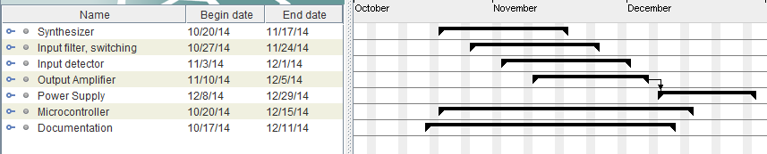

Figure : Top-level Gantt chart, Fall

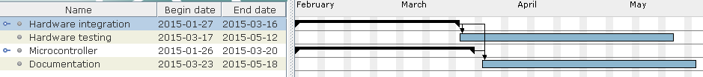

Figure : Top-level Gantt chart, Spring

Detailed schedules can be found at “Figure 5: Detailed Fall Schedule” and “Figure 6: Detailed Spring Schedule”, in Appendix A – Detailed Project Schedule.

## Project Finances

WCP: **What’s it going to cost?** Provide a top-level financial summary as a one-page table with expended, estimate-to-completion, and estimate-at-completion columns, and summary comparison to budget.

|  |  |  |  |
| --- | --- | --- | --- |
| **Item** | **Expended** | **Estimate to Compl.** | **Estimate at Compl.** |
| Synthesizer prototype and parts | $20 | $90 | $90 |
| Input prototype and parts | $0 | $40 | $40 |
| Detector prototype and parts | $0 | $50 | $50 |
| Output amplifier proto. and parts | $0 | $50 | $50 |
| Power supply proto. and parts | $0 | $20 | $20 |
| Final PCB and parts | $0 | $120 | $120 |
| Enclosure | $0 | $30 | $30 |
| Miscellaneous/re-spins | $0 | $100 | $100 |
| **Total** | **$0** | **$500** | **$500** |

Table 1: Project Finance Estimation

The estimated budget total at this point is $500. Of this, 20% is reserved for unforeseen excess costs.

## Project Resources

WCP: Describe the other resources to be applied to the project, including, as applicable:

1. Overview of developer facilities to be used, including geographic locations in which the work will be performed, facilities to be used, and other features of the facilities as applicable to the project effort.

Work shall be performed on the Binghamton University campus, or at students’ homes with team-owned equipment. Campus facilities to be used are electronics labs and the student work shop.

1. Acquirer-furnished equipment, software, services, documentation, data, and facilities required for the project effort. A schedule detailing when these items will be needed shall also be included.
2. Other required resources, including a plan for obtaining the resources, dates needed, and availability of each resource item.

WCP: **What do you need to get the job done?** Describe what machine tools, soldering systems, painting facilities, test equipment, etc. will be needed, with specific capabilities required, and where you expect to get them. Especially note anything you need from the system acquirer (your customer), and when!

The project will require the following equipment, which will be borrowed from the University when available or otherwise provided by the team:

* Oscilloscope, at least 400 MHz bandwidth required, at least 800 MHz preferred.
* Signal generator, at least 100 MHz output.
* Logic analyzer, easily provided by team.
* Power supplies, at least 15V: three supplies, or any combination of three outputs from multi-output supplies.

WCP: **What’s your procurement plan?** Can you afford to buy everything and get reimbursed? Will your project sponsor be buying items for you? Will you get them in time?

Everything that needs to be purchased can be afforded within the WCP budget and reimbursed. All parts will be ordered by the end of the fall semester and will be available for use and testing before the beginning of the spring semester.

WCP: This section shall contain any general information that aids in understanding this document (e.g., background information, glossary, rationale).

WCP: No text needed here – it’s a top-level heading with subsections.

## Acronyms and Abbreviations

WCP: Provide an alphabetical listing of all acronyms, abbreviations, and their meanings as used in this document and a list of any terms and definitions needed to understand this document.

WCP: Start with these:

CAE Computer-Aided Engineering

CDR Critical Design Review

CSG Coding Style Guidelines

DUT Device Under Test

GCC GNU Compiler Collection

RMS Root-Mean-Square

PC Personal Computer

PDP Project Development Plan

PDR Preliminary Design Review

PRS Project Requirements Specification

PTPP Project Test Plan and Procedures

SAR System Acceptance Review

SDR System Design Review

SOW Statement of Work

SRR System Requirements Review

TRR Test Readiness Review

WCP Watson Capstone Projects

# Appendices

WCP: Appendixes may be used to provide information published separately for convenience in document maintenance (e.g., charts, classified data). As applicable, each appendix shall be referenced in the main body of the document where the data would normally have been provided. Appendixes may be bound as separate documents for ease in handling. Appendixes shall be lettered alphabetically (A, B, etc.). Appendices may have their page numbers preceded by the appendix letter and a dash (e.g, A-).

* 1. Appendix A – Detailed Project Schedule

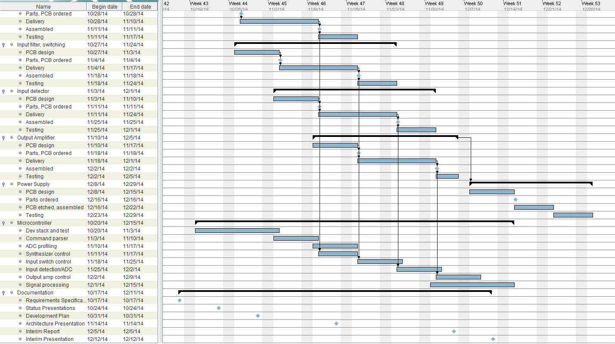

Figure : Detailed Fall Schedule

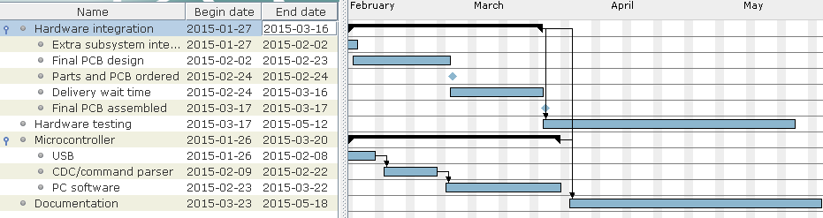

Figure : Detailed Spring Schedule